**INTERNET OF THINGS (IoT)**

IMPROVING TRAFFIC PROBLEMS



**MINOR PROJECT SUBMITED IN PRATIAL**

**FULFILMENT OF THE REQUIREMENT FOR THE**

**DEGREE IN BACHELOR OF TECHNOLOGY**

Submitted By: -

SUNIL KUMAR

SHAHNAWAZ NAYYAR

Under the guidance of

Dr. Vivek Aggarwal

DEPARTMENT OF APPLIED MATHEMATICS,

DELHI TECHNOLOGICAL UNIVERSITY, DELHI

**BONAFIDE CERTIFICATE**

This is to certify that this project report entitled “**Internet of things(Iot):improving traffic problems**” submitted to Department of Applied Mathematics, is a bonafide record of work done by “**SUDHIR KUMAR**”, Roll Number “**2K14/MC/086**” under my supervision from “ 1 oct 2016” to “19 Nov 2016”.

Dr. Vivek Aggarwal

Assistant Professor

(Department of Applied Mathematics)

Delhi technological University

Place: Delhi

Date:

**Declaration by Author**

This is to declare that this report has been written by us. No part of the report is plagiarized from other sources All information included from other sources have been duly acknowledged. We declare that if any part of the report is found to be plagiarized, we shall take full responsibility for it.

SUDHIR KUMAR

2K14/MC/086

Place: Delhi

Date:

INTRODUCTION

Internet of Things(Iot): -

The **Internet of things** is the [internetworking](https://en.wikipedia.org/wiki/Internetworking) of physical devices, vehicles, buildings and other items—[embedded](https://en.wikipedia.org/wiki/Embedded_system) with [electronics](https://en.wikipedia.org/wiki/Electronics), [software](https://en.wikipedia.org/wiki/Software), [sensors](https://en.wikipedia.org/wiki/Sensor), actuators, and [network connectivity](https://en.wikipedia.org/wiki/Internet_access) that enable these objects to collect and exchange data. In 2013 the Global Standards Initiative on Internet of Things (IoT-GSI) defined the IoT as "the infrastructure of the information society."[3] The IoT allows objects to be sensed and/or controlled remotely across existing network infrastructure, creating opportunities for more direct integration of the physical world into computer-based systems, and resulting in improved efficiency, accuracy and economic benefit. When IoT is augmented with sensors and actuators, the technology becomes an instance of the more general class of [cyber-physical systems](https://en.wikipedia.org/wiki/Cyber-physical_system), which also encompasses technologies such as [smart grids](https://en.wikipedia.org/wiki/Smart_grid), [smart homes](https://en.wikipedia.org/wiki/Smart_home), [intelligent transportation](https://en.wikipedia.org/wiki/Intelligent_transportation) and [smart cities](https://en.wikipedia.org/wiki/Smart_city). Each thing is uniquely identifiable through its embedded computing system but is able to interoperate within the existing [Internet](https://en.wikipedia.org/wiki/Internet) infrastructure. Experts estimate that the IoT will consist of almost 50 billion objects by 2020.

Typically, IoT is expected to offer advanced connectivity of devices, systems, and services that goes beyond [machine-to-machine](https://en.wikipedia.org/wiki/Machine_to_machine) (M2M) communications and covers a variety of protocols, domains, and applications.[[12]](https://en.wikipedia.org/wiki/Internet_of_things#cite_note-M2M-IoT-12) The interconnection of these embedded devices expected to usher in automation in nearly all fields, while also enabling advanced applications like a [smart grid](https://en.wikipedia.org/wiki/Smart_grid), and expanding to the areas such as [smart cities](https://en.wikipedia.org/wiki/Smart_city).

"Things," in the IoT sense, can refer to a wide variety of devices such as heart monitoring implants, [biochip](https://en.wikipedia.org/wiki/Biochip) transponders on farm animals, electric clams in coastal waters,[[16]](https://en.wikipedia.org/wiki/Internet_of_things#cite_note-MolluSCAN_eye-16) automobiles with built-in sensors, DNA analysis devices for environmental/food/pathogen monitoring[[17]](https://en.wikipedia.org/wiki/Internet_of_things#cite_note-Erlich2015-17) or field operation devices that assist firefighters in [search and rescue](https://en.wikipedia.org/wiki/Search_and_rescue) operations.[[18]](https://en.wikipedia.org/wiki/Internet_of_things#cite_note-Definition-IoT-18) Legal scholars suggest to look at "Things" as an "inextricable mixture of hardware, software, data and service".[[19]](https://en.wikipedia.org/wiki/Internet_of_things#cite_note-19) These devices collect useful data with the help of various existing technologies and then autonomously flow the data between other devices.[[20]](https://en.wikipedia.org/wiki/Internet_of_things#cite_note-20) Current market examples include [home automation](https://en.wikipedia.org/wiki/Home_automation) (also known as smart home devices) such as the control and automation of lighting, heating (like [smart thermostat](https://en.wikipedia.org/wiki/Smart_thermostat)), ventilation, air conditioning (HVAC) systems, and appliances such as washer/dryers, robotic vacuums, air purifiers, ovens or refrigerators/freezers that use Wi-Fi for remote monitoring.

As well as the expansion of Internet-connected automation into a plethora of new application areas, IoT is also expected to generate large amounts of data from diverse locations, with the consequent necessity for quick aggregation of the data, and an increase in the need to index, store, and process such data more effectively. IoT is one of the platforms of today's Smart City, and Smart Energy Management Systems.

What Forbes has to say about it?

**A Simple Explanation Of 'The Internet of Things'**

There are a lot of complexities around the “Internet of things” but I want to stick to the basics. Lots of technical and policy-related conversations are being had but many people are still just trying to grasp the foundation of what the heck these conversations are about.

Let’s start with understanding a few things.

Broadband Internet is become more widely available, the cost of connecting is decreasing, more devices are being created with Wi-Fi capabilities and sensors built into them, technology costs are going down, and smartphone penetration is sky-rocketing.  All of these things are creating a “perfect storm” for the IoT.

Simply put, this is the concept of basically connecting any device with an on and off switch to the Internet (and/or to each other). This includes everything from cell phones, coffee makers, washing machines, headphones, lamps, wearable devices and almost anything else you can think of.  This also applies to components of machines, for example a jet engine of an airplane or the drill of an oil rig. As I mentioned, if it has an on and off switch then chances are it can be a part of the IoT.

**How Does This Impact Us?**

The new rule for the future is going to be, “Anything that can be connected, will be connected.” But why on earth would you want so many connected devices talking to each other? There are many examples for what this might look like or what the potential value might be. Say for example you are on your way to a meeting; your car could have access to your calendar and already know the best route to take. If the traffic is heavy your car might send a text to the other party notifying them that you will be late. What if your alarm clock wakes up you at 6 a.m. and then notifies your coffee maker to start brewing coffee for you? What if your office equipment knew when it was running low on supplies and automatically re-ordered more?  What if the wearable device you used in the workplace could tell you when and where you were most active and productive and shared that information with other devices that you used while working?

On a broader scale, the IoT can be applied to things like transportation networks: “smart cities” which can help us reduce waste and improve efficiency for things such as energy use; this helping us understand and improve how we work and live. Take a look at the visual below to see what something like that can look like.

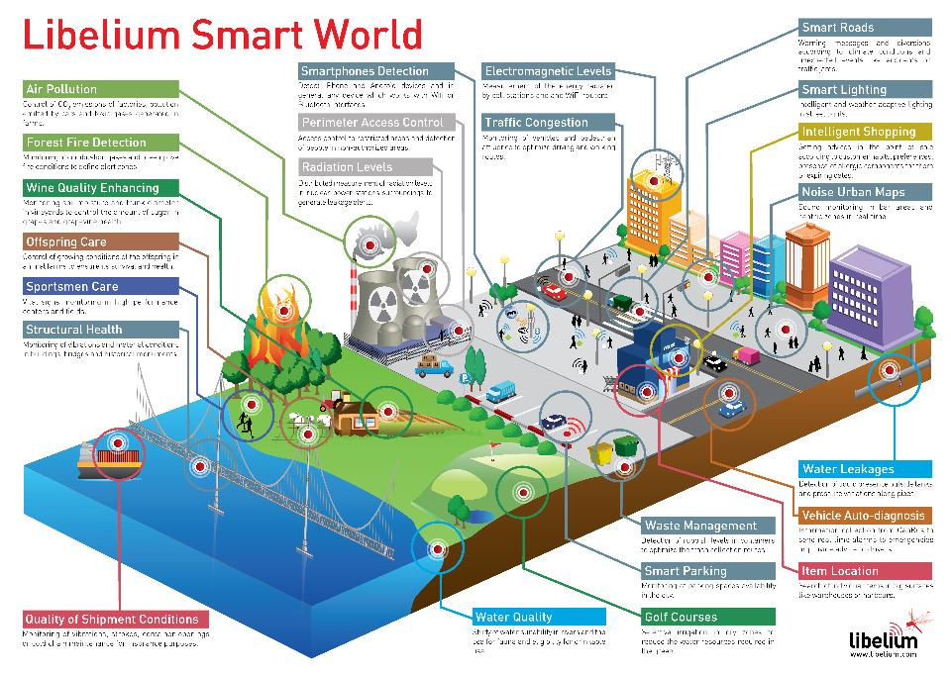

The reality is that the IoT allows for virtually endless opportunities and connections to take place, many of which we can’t even think of or fully understand the impact of today. It’s not hard to see how and why the IoT is such a hot topic today; it certainly opens the door to a lot of opportunities but also to many challenges. [Security](http://www.forbes.com/security/) is a big issue that is oftentimes brought up. With billions of devices being connected together, what can people do to make sure that their information stays secure? Will someone be able to hack into your toaster and thereby get access to your entire network? The IoT also opens up companies all over the world to more security threats. Then we have the issue of privacy and data sharing. This is a hot-button topic even today, so one can only imagine how the conversation and concerns will escalate when we are talking about many billions of devices being connected. Another issue that many companies specifically are going to be faced with is around the massive amounts of data that all of these devices are going to produce. Companies need to figure out a way to store, track, analyse and make sense of the vast amounts of data that will be generated.

So, what now?

Conversations about the IoT are (and have been for several years) taking place all over the world as we seek to understand how this will impact our lives. We are also trying to understand what the many opportunities and challenges are going to be as more and more devices start to join the IoT. For now, the best thing that we can do is educate ourselves about what the IoT is and the potential impacts that can be seen on how we work and live.

APPLICATION OF Internet of Things

## Smart Cities

* **01**

**Smart Parking**  
Monitoring of parking spaces availability in the city.

* **02**

**Structural health**  
Monitoring of vibrations and material conditions in buildings, bridges and historical monuments.

* **03**

**Noise Urban Maps**  
Sound monitoring in bar areas and centric zones in real time.

* **04**

**Smartphone Detection**  
Detect iPhone and Android devices and in general any device which works with Wi-Fi or Bluetooth interfaces.

* **05**

**Electromagnetic Field Levels**  
Measurement of the energy radiated by cell stations and and Wi-Fi routers.

* **06**

**Traffic Congestion**  
Monitoring of vehicles and pedestrian levels to optimize driving and walking routes.

* **07**

**Smart Lighting**  
Intelligent and weather adaptive lighting in street lights.

* **08**

**Waste Management**  
Detection of rubbish levels in containers to optimize the trash collection routes.

* **09**

**Smart Roads**  
Intelligent Highways with warning messages and diversions according to climate conditions and unexpected events like accidents or traffic jams.

## Smart Environment

* **1**

**Forest Fire Detection**  
Monitoring of combustion gases and pre-emptive fire conditions to define alert zones.

* **2**

**Air Pollution**  
Control of CO2 emissions of factories, pollution emitted by cars and toxic gases generated in farms.

* **3**

**Snow Level Monitoring**  
Snow level measurement to know in real time the quality of ski tracks and allow security corps avalanche prevention.

* **4**

**Landslide and Avalanche Prevention**  
Monitoring of soil moisture, vibrations and earth density to detect dangerous patterns in land conditions.

* **5**

**Earthquake Early Detection**  
Distributed control in specific places of tremors.

## Smart Water

* **1**

**Potable water monitoring**  
Monitor the quality of tap water in cities.

* **2**

**Chemical leakage detection in rivers**  
Detect leakages and wastes of factories in rivers.

* **3**

**Swimming pool remote measurement**  
Control remotely the swimming pool conditions.

* **4**

**Pollution levels in the sea**  
Control real-time leakages and wastes in the sea.

* **5**

**Water Leakages**  
Detection of liquid presence outside tanks and pressure variations along pipes.

* **6**

**River Floods**  
Monitoring of water level variations in rivers, dams and reservoirs.

## Smart Metering

* **1**

**Smart Grid**  
Energy consumption monitoring and management.

* **2**

**Tank level**  
Monitoring of water, oil and gas levels in storage tanks and cisterns.

* **3**

**Photovoltaic Installations**  
Monitoring and optimization of performance in solar energy plants.

* **4**

**Water Flow**  
Measurement of water pressure in water transportation systems.

* **5**

**Silos Stock Calculation**  
Measurement of emptiness level and weight of the goods.

## Security & Emergencies

* **1**

**Perimeter Access Control**  
Access control to restricted areas and detection of people in non-authorized areas.

* **2**

**Liquid Presence**  
Liquid detection in data center, warehouses and sensitive building grounds to prevent break downs and corrosion.

* **3**

**Radiation Levels**  
Distributed measurement of radiation levels in nuclear power stations surroundings to generate leakage alerts.

* **4**

**Explosive and Hazardous Gases**  
Detection of gas levels and leakages in industrial environments, surroundings of chemical factories and inside mines.

## Retail

* **1**

**Supply Chain Control**  
Monitoring of storage conditions along the supply chain and product tracking for traceability purposes.

* **2**

**NFC Payment**  
Payment processing based in location or activity duration for public transport, gyms, theme parks, etc.

* **3**

**Intelligent Shopping Applications**  
Getting advices in the point of sale according to customer habits, preferences, presence of allergic components for them or expiring dates.

* **4**

**Smart Product Management**  
Control of rotation of products in shelves and warehouses to automate restocking processes.

## Logistics

* **1**

**Quality of Shipment Conditions**  
Monitoring of vibrations, strokes, container openings or cold chain maintenance for insurance purposes.

* **2**

**Item Location**  
Search of individual items in big surfaces like warehouses or harbours.

* **3**

**Storage Incompatibility Detection**  
Warning emission on containers storing inflammable goods closed to others containing explosive material.

* **4**

**Fleet Tracking**  
Control of routes followed for delicate goods like medical drugs, jewels or dangerous merchandises.

## Industrial Control

* **1**

**M2M Applications**  
Machine auto-diagnosis and assets control.

* **2**

**Indoor Air Quality**  
Monitoring of toxic gas and oxygen levels inside chemical plants to ensure workers and goods safety.

* **3**

**Temperature Monitoring**  
Control of temperature inside industrial and medical fridges with sensitive merchandise.

* **4**

**Ozone Presence**  
Monitoring of ozone levels during the drying meat process in food factories.

* **5**

**Indoor Location**  
Asset indoor location by using active (ZigBee) and passive tags (RFID/NFC).

* **6**

**Vehicle Auto-diagnosis**  
Information collection from Can Bus to send real time alarms to emergencies or provide advice to drivers.

## Smart Agriculture

* **1**

**Wine Quality Enhancing**  
Monitoring soil moisture and trunk diameter in vineyards to control the amount of sugar in grapes and grapevine health.

* **2**

**Green Houses**  
Control micro-climate conditions to maximize the production of fruits and vegetables and its quality.

* **3**

**Golf Courses**  
Selective irrigation in dry zones to reduce the water resources required in the green.

* **4**

**Meteorological Station Network**  
Study of weather conditions in fields to forecast ice formation, rain, drought, snow or wind changes.

* **5**

**Compost**  
Control of humidity and temperature levels in alfalfa, hay, straw, etc. to prevent fungus and other microbial contaminants.

## Smart Animal Farming

* **1**

**Hydroponics**  
Control the exact conditions of plants grown in water to get the highest efficiency crops.

* **2**

**Offspring Care**  
Control of growing conditions of the offspring in animal farms to ensure its survival and health.

* **3**

**Animal Tracking**  
Location and identification of animals grazing in open pastures or location in big stables.

* **4**

**Toxic Gas Levels**  
Study of ventilation and air quality in farms and detection of harmful gases from excrements.

## Domestic & Home Automation

* **1**

**Energy and Water Use**  
Energy and water supply consumption monitoring to obtain advice on how to save cost and resources.

* **2**

**Remote Control Appliances**  
Switching on and off remotely appliances to avoid accidents and save energy.

* **3**

**Intrusion Detection Systems**  
Detection of windows and doors openings and violations to prevent intruders.

* **4**

**Art and Goods Preservation**  
Monitoring of conditions inside museums and art warehouses.

## eHealth

* **1**

**Fall Detection**  
Assistance for elderly or disabled people living independent.

* **2**

**Medical Fridges**  
Control of conditions inside freezers storing vaccines, medicines and organic elements.

* **3**

**Sportsmen Care**  
Vital signs monitoring in high performance centers and fields.

* **4**

**Patients Surveillance**  
Monitoring of conditions of patients inside hospitals and in old people's home.

* **5**

**Ultraviolet Radiation**  
Measurement of UV sun rays to warn people not to be exposed in certain hours.

Topic For Project:-

Improving traffic problems using iot

The basic idea, is about connecting “things” together to make the city traffic and transportation systems more intelligent. For example, by connecting traffic cameras to vehicles’ GPS, we can have a better understanding of traffic flows. It is also possible to send an SMS message to commuters to warn them about potential traffic congestion and help them to avoid it. The result is an enhanced commuter experience, a reduction in traffic congestion and a more efficient, safer and more secure traffic and transportation system.

The IoT plays an instrumental role here by collecting data from various sources such as traffic cameras, commuters’ mobile phones, vehicles’ GPS, sensors on the roads, passing vehicles and so on. This data is analyzed to understand traffic flows and usage patterns, enabling us to find new ways to optimize the most frequently used roads and transportation methods. Connected loop detectors that monitor conditions on roads can also detect hazardous conditions. Accordingly, maintenance crews are then dispatched to respond in a timely manner. Vehicle drivers are also warned about hazardous conditions to avoid, thus reducing the number of road accidents and increasing overall safety and security.

IBM has designed that solution under the name of [IBM Intelligent Transportation](http://www-03.ibm.com/software/products/en/intelligent-transportation?ce=ISM0345&ct=sp&cmp=ibmsocial&cm=h&cr=mf&ccy=us) to provide intelligence and insights across the traffic and transportation network. It helps to analyze traffic behavior and events in order to optimize traffic flow and increase the efficiency of the whole traffic and transportation system. IBM Intelligent Transportation is designed to fulfill the following functions:

* **Consolidate traffic data coming from different sources** such as roadway systems (including traffic lights, variable message signs [VMSs], variable speed signs [VSSs] and lane signals) and road reporting systems (including microwave sensors, video cameras and telematics; vehicles on the roads; roadside sensors). All of these data sources are aggregated, normalized and transformed into a standard traffic information model.
* **Analyze traffic information to provide near-real-time insights** about traffic performance, conditions and incidents and thus help optimize the flow of traffic. Correlation with historical data can also be performed to provide traffic operators with a view into the likely (near-term) traffic flow. This can help them to proactively set traffic signals or suggest road detours, which can help to reduce traffic congestion. It can also help road travelers better plan their commute routes.
* **Monitor traffic operations and incidents** through a centralized management dashboard that collects information from different geographic locations across the city. This information is visualized on a geospatial map indicating the general traffic flow and congested areas to help traffic planners and operators manage traffic performance and further optimize their response to different incidents.
* **Support the storage and presentation of geographic information system** (GIS) data for dynamic graphical displays in the dashboard to visualize things such as the road network, traffic volume, speed, density and traffic incidents. It can also display icons for devices that are spread across the city such as traffic cameras, traffic lights or any other control device to view their detailed information.

SINGAPORE CURRENTLY USING Iot for traffic problems

Singapore, long known as a technology leader in Asia, is now bringing those advancements to the streets – literally. As part of its Smart Nation initiative, Singapore plans to combine technologies such as the cloud, [Internet of Things](http://www.internetofyourthings.com/), and data analysis with its strong public infrastructure and forward looking government. But fully achieving that vision will require academics, businesses, and startups to join in solving some of the world’s toughest societal challenges.

[In a post on the Microsoft CityNext blog](http://enterprise.microsoft.com/en-us/industries/citynext/how-singapore-is-realising-the-true-power-of-iot/) Jean-Philippe Courtois, president, Microsoft International, reports on how Singapore is taking its first step in achieving this vision by using IoT to tackle traffic management issues. Traffic cameras and traffic lights record volumes of data. Since 2011, the Land Transport Authority of Singapore (LTA) has hosted a central hub where traffic data can be collected and used to improve traffic flow. The LTA uses the Microsoft Azure platform to host the data and get real-time insights that they then use to make decisions. The organization also makes the data available publicly, empowering developers to create unique mobile apps while pulling data from LTA.

Courtois also notes that IoT can have an important impact on a variety of verticals, from manufacturing and oil and gas to building management and healthcare.

In healthcare, for example, individuals are using wearable technology to monitor health and well-being beyond their heartrate, and physicians could use this data to monitor patients remotely. Researchers are gathering big data sets that could potentially lead to earlier diagnoses, and eventually cures, for some diseases.

These are just two examples of how technology and the Smart Nation concept could improve lives. Singapore is leading the way, but Courtois is hopeful other nations will follow suit.

CHANGE TRAFFIC SIGNAL ACCORDING TO VEHICLE

COUNTINGs USING SENSORS

MATERIALS:-

1)Gateway:-

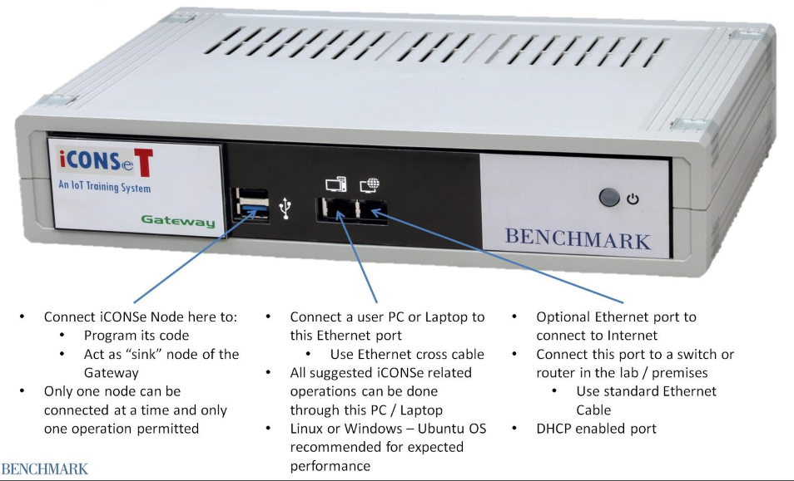

2)Node:-

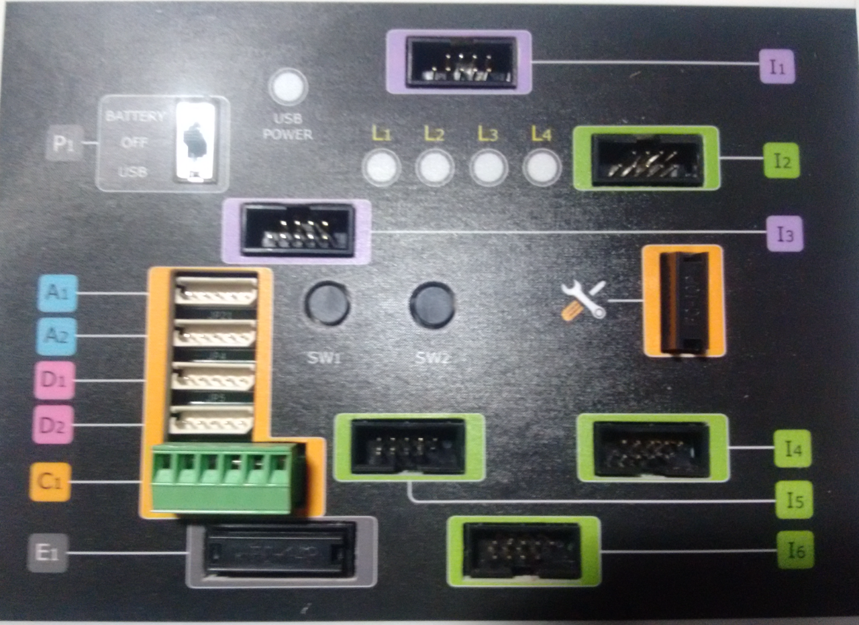

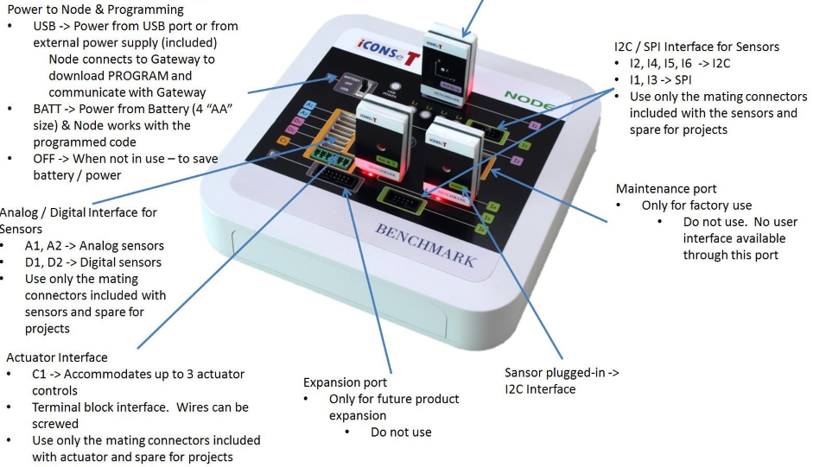

3)Sensors: 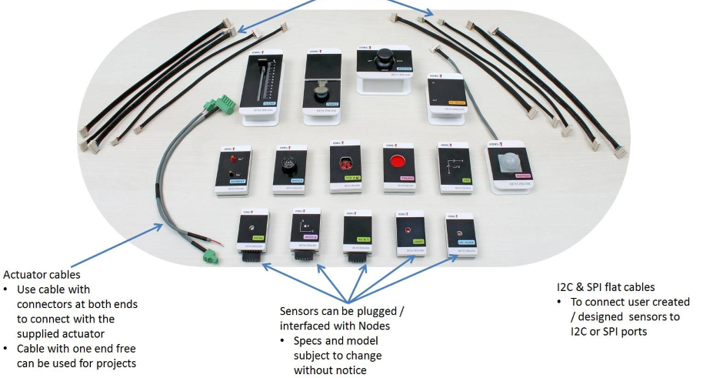

4)LAN cable,PC and basic traffic equipment

THEORY And Explanation Of the project

The basic principle is the use of Iot technology, our traffic system will be connected to a setup of Iot which will need to be setup by professionals as a slight error can cause an error in reading of the data, this will then will be monitored by both by human and by computers using AI according to the need .Sensors will be set up around various blocks of the road to properly giving accurate results, here we will be using the photo or light sensors(12 C) which will be telling the range in which vehicles are present and with proper coding and monitoring will be telling the amount of vehicle present. Information of the sensors which will then send this data to the node where it is connected to a I6 port, which is shown in fig, this node will then send this data to a gateway, the gateway connected converts this information to a computer readable form or in other word in a stream of bits which is easily readable by computer. Here it is important to notice that that gateway can send data to a computer either by directly connecting with a LAN or USB cable or else it can send this data over internet(WAN/PAN/LAN),this is the good thing about Iot that it can be managed and monitored over any place where there is availability of network and hence make it easy for various institution responsible for traffic can apply and help reducing the traffic problem, the data send by the gateway to a computer will be then monitored and by using some defined rules(coding) the traffic light can be turned red or green according to the desire or in our case will be red if there is no vehicle present at that time and will turn green in opposite situations.

We want the traffic problems of the a country like India to be solved, it isn’t the a major step but it is a step, the problem which we are dealing is the undesired green light shown by the traffic signal even if there is no vehicle present at that time on that particular road in respect to showing red light to the opposite road where the vehicle count is increasing with every going seconds. It does not affect where the interval time is less but during peak hours such a slight save in time can make a big difference.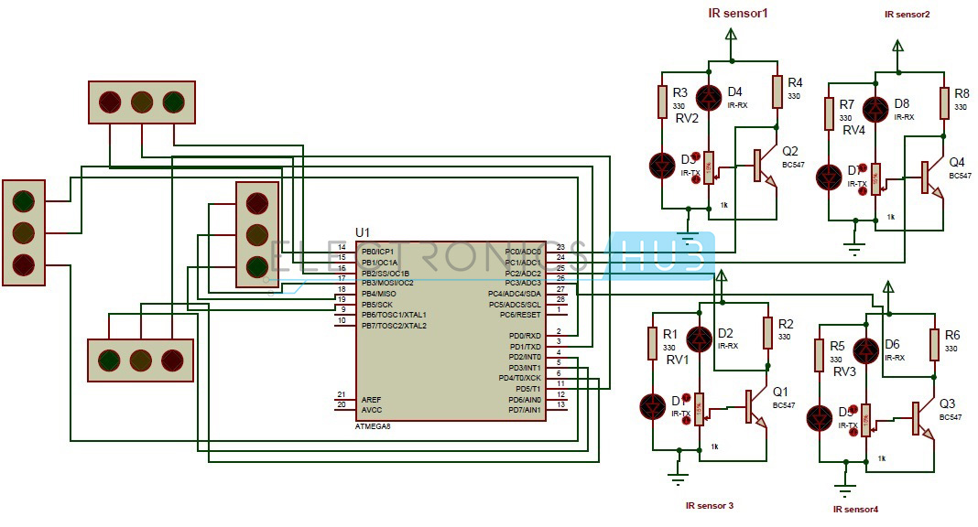

**COMBINING MICROCONTROLLERs**

In this system IR sensors are used to measure the density of the vehicles which are fixed within a fixed distance. All the sensors are interfaced with the microcontroller which in turn controls the traffic signal system according to density detected by the sensors. If the traffic density is high on particular side more priority is given for that side. The sensors continuously keep sensing density on all sides and the green signal is given to the side on priority basis, where the sensors detect high density. The side with next priority level follows the first priority level. By using this system traffic can be cleared without irregularities and time delay seven though there is no traffic on the other side can be avoided

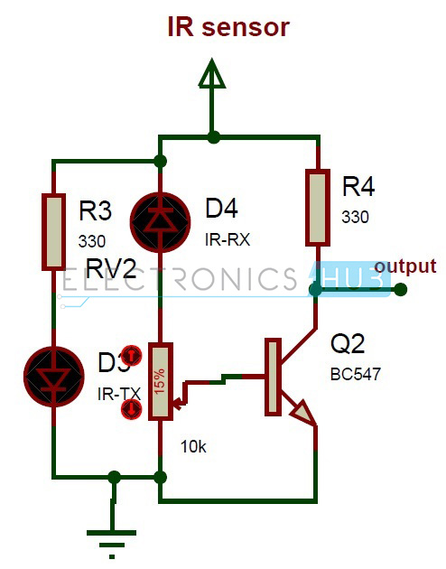

#### **Limitations of the IR sensors:**

* IR sensors sometimes may absorb normal light also. As a result, traffic system works in improper way.
* IR sensors work only for fewer distances.
* We have to arrange IR sensors in accurate manner otherwise they may not detect the traffic density.

**CCTV:An eye for traffic controlling**

**(Image Processing using Matlab & Opencv)**

**MATLAB**

The proposed system adapts the traffic signal timer according to the random traffic density using image processing techniques. This model uses high resolution cameras to sense the changing traffic patterns around the traffic signal and manipulates the signal timer accordingly by triggering the signals to the timercontrol system. The increase and decrease in traffic congestion directly depends upon the control on the flow of traffic, and hence, on the traffic signal timer. Due to this phenomenon, the vehicles have to face an irregular delay during transit in the urban areas. At present, the traffic control systems in India, lack intelligence and act as an open-loop control system, with no feedback or sensing network. The aim in this work was to improve the traffic control system by introducing a sensing network, which provides a feedback to the existing network; so that it can adapt the changing traffic density patterns and provides necessary signals to the controller in real time operation.

The objective is to design an intelligent traffic signal control system algorithm with the use of sensing devices and image processing systems. The captured images were to be processed in real time using an image processing toolkit such as MATLAB, and various parameters have to be calculated to estimate the density of vehicle traffic in all four directions. The controller has to execute the developed algorithm on the traffic signal timer to vary its time period.

This autonomous control system consists of four major entities,

1. High resolution imaging device.
2. Image processing tool –MATLAB® R2013a.
3. Microcontroller based traffic light timer control.
4. Wireless transmission using UART principles.

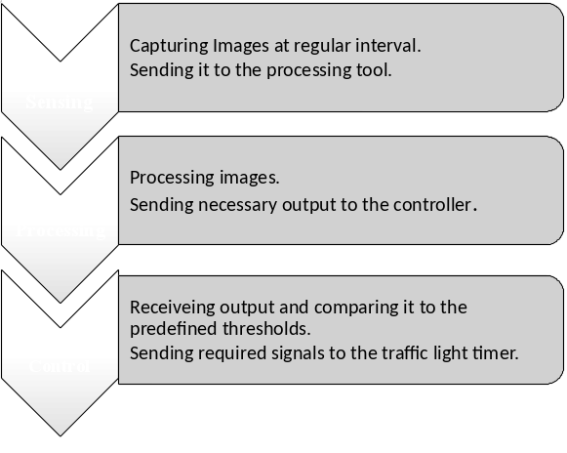

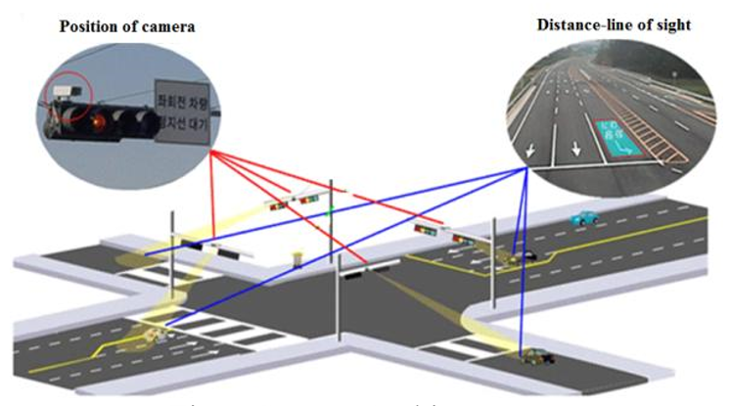

The Image Processing Algorithm proceeds in the following way. Assuming day time analysis, four snapshots of each of the four directions is captured, with the help of high resolution cameras, when there is negligible density of vehicles on the road. These four images act as a reference. For the remaining part of the day the images are captured at regular interval of 5 seconds and then compared with the reference images using image processing techniques described through images below.

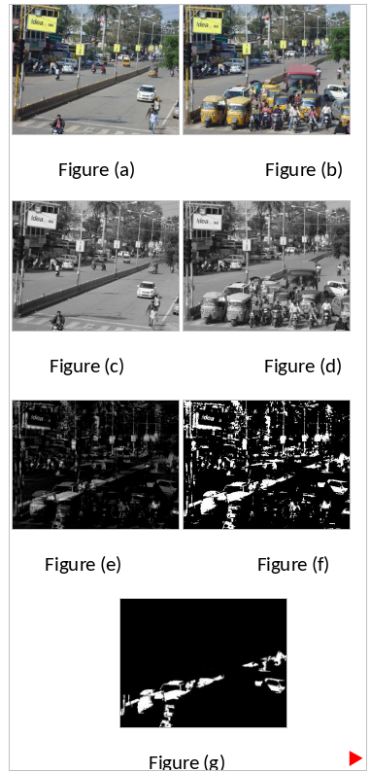

Fig (a) represents the reference image in one direction of a four way intersection. Fig (b) is the real-time image which is captured at regular interval. Now both, fig (a) and fig (b) are converted into greyscale using rgb2gray command in MATLAB, as shown in fig (c) & fig (d) respectively. Now for estimation of real-time traffic density we subtract fig (c) from fig (d) Using imsubstract command, which results in fig (e). Now as it requires to define the threshold levels for digital signal processing, we use graythresh command and for better differentiability fig (e) is converted into a binary image using im2bw command as shown in fig (f). Still to remove the low density areas, such as birds, banners, streetlights etc., a filter is required for optimised results. This filtering process is executed using command bwareopen which is shown in fig (g). The white portion on the image represents the traffic density, so the percentage of white portion is calculated and its value is send to controller for further calculations and timer manipulation.

**USING OPENCV**

**DENSITY MEASUREMENT**

In this system the source image is the RGB image which can be given by the users for getting the contour image and the vehicle count in output screen. The following code can be used to auto size of the output screen .

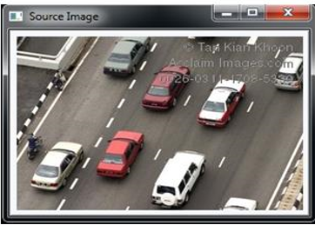

Fig. Source image

B.Grayscale Image:-

The grayscale image can be used to display the objects in the format of black and white. In this system the output will be display the grayscale image after getting the source image only, because source image only converted into the grayscale image.

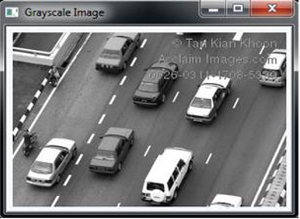

. Fig 3 Gray Scale Image C. Threshold Image

The threshold image brightness or contrast of the grayscale image. In this system we can convert the grayscale image to threshold image

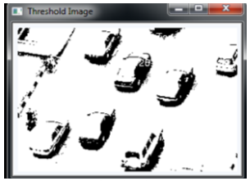

Canny image is the image one of the edge detector that can be used to outline the edges of the objects. It can be help full for find out the objects.Here we have convet the threshold image to canny image

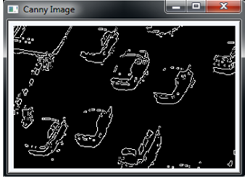

Fig. 5 Canny Image E .Erode Image

The Erode image:- also like the canny image it can be used find the edges with the darked lines.In our system the edges of the vehicles are detect with the darked lines Before converting the canny image to Erode image, the canny image will be destroied.

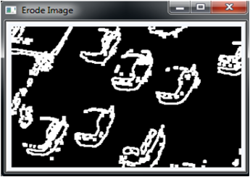

Fig. 6 Erode Image F. Contour Image Before showing the vehicles count and output screen the Erode Image converted into the contour image. This image is the final step to find the vehicled counts and output screen.

The two types of output screens are displyed in this system.

1) First output screen disply the output image. In this image will display the original RGB Image and in this screen the vehicles are boxed for the find the count.

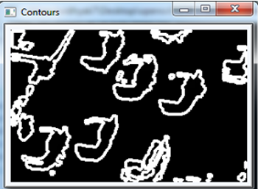

2) Another output screen is the command prompt. In this command prompt will be open when the user run this system, in final stage after getting the output image the command promt will display the vehicle counts.

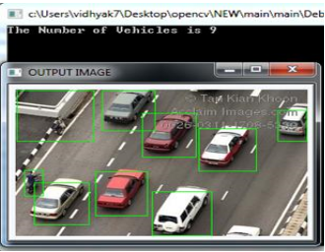

Fig. Output Image H.

Digital Image Processing Digital image processing is the use of computer algorithms to perform image processing on digital images. As a subfield of digital signal processing, digital image processing has many advantages over analog image processing; it allows a much wider range of algorithms to be applied to the input data, and can avoid problems such as the build-up of noise and signal distortion during processing.

**Disadvantage:**

Interpreted programming language, slower than C++ and V. FORTRAN. This tool cannot be used for real time application it will give only the simulation results.Matlab software is not free of cost. Our application requires the real time application software so opencv is used as the image processing technique.

**ACKNOWLEDGEMENT**

First and foremost, I would like to express my gratitude to our guide ***Dr. VIVEK AGGARWAL*** sir and other faculty members for giving us a wonder full opportunity to work on this project titled Internet of thing. we are thankful to him who was always ready to lend some of the very interesting feauteres of Internet. I am very grateful to him in introducing some very exciting features of Iot.

We are also thankful to all my teachers of DELHI TECHNOLOGICAL UNIVERSITY, who were simply full of idea and whenever there was any need they shared those great ideas and concept with us.And in the end we would like to thank all those who helped us during the testing phase of the project.

THANKING YOU…